**//WAP in Drupal to Create Content, Modify Content, Publish Content, Menu Management.**

Step 1- Login in WordPress Administrator (Node)

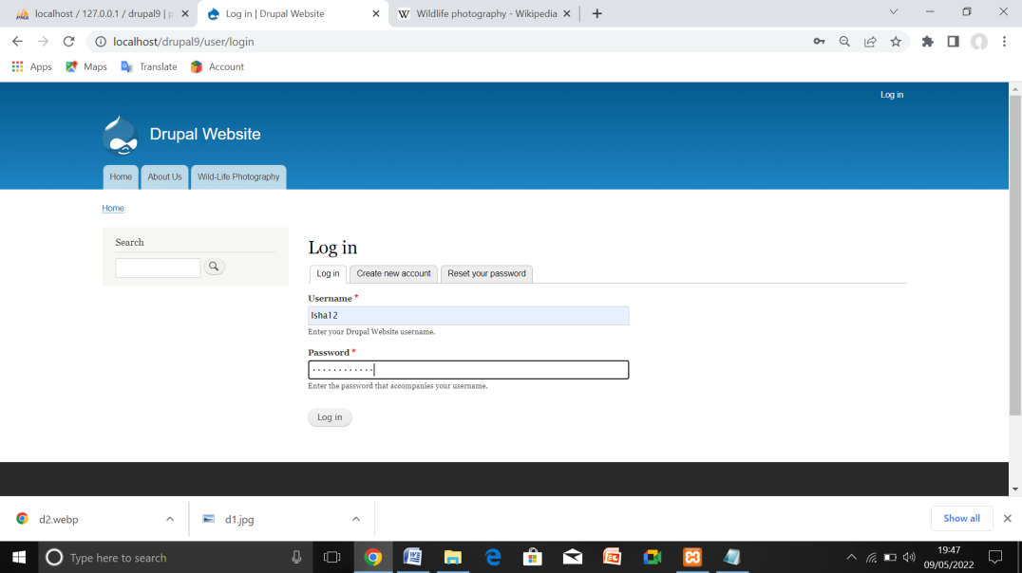

Step 2 Select Content option and add new Content

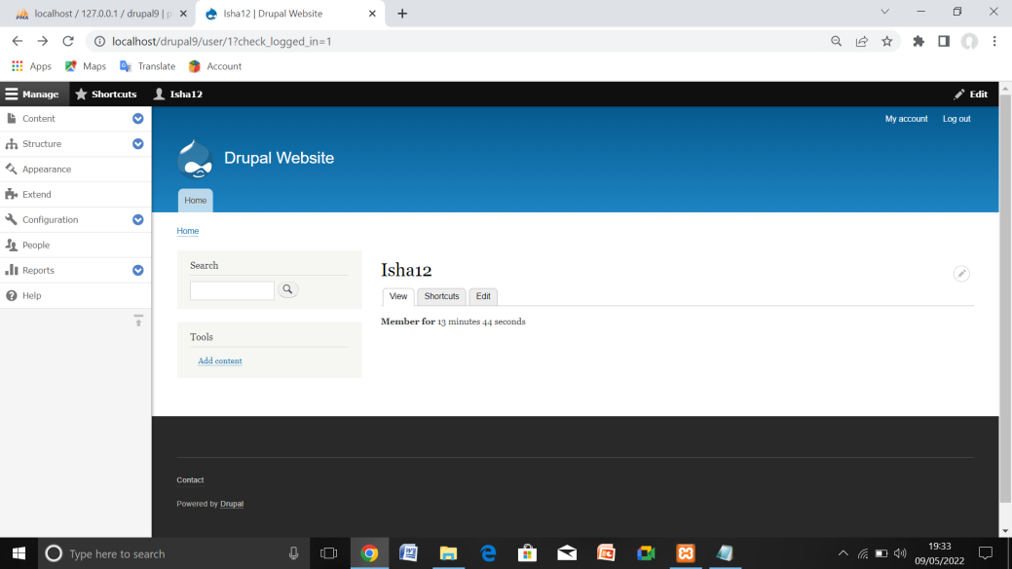

Step 3- Content > Add content > Basic page (node/add/page).

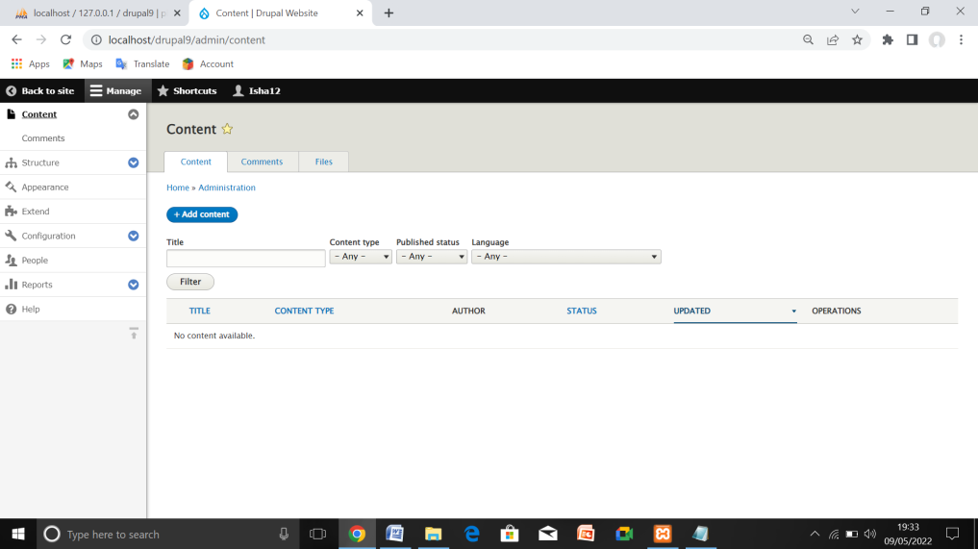

Step 4- The Create Basic page form appears.

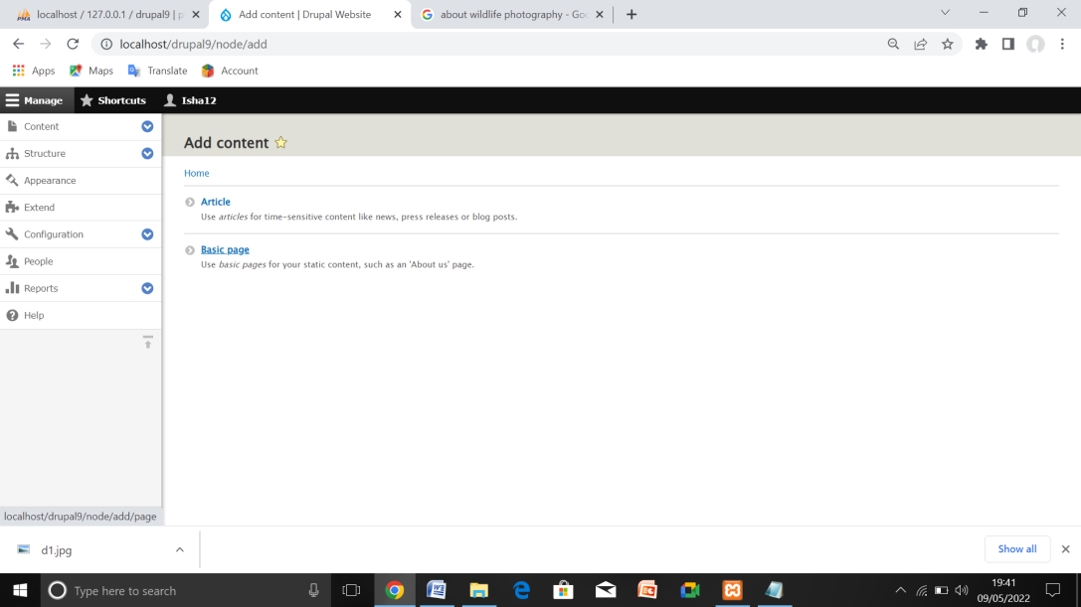

Step 5- To add text, you just click and type.

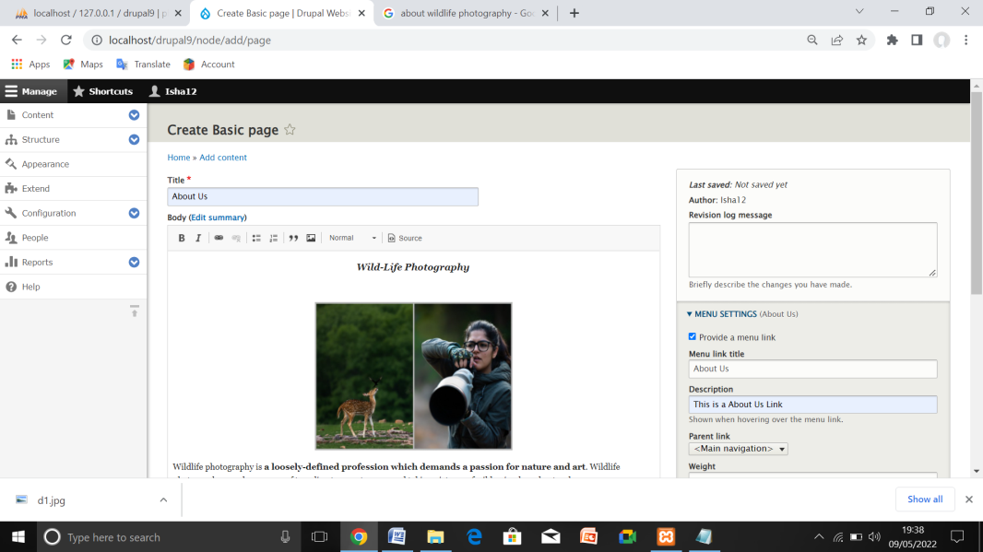

Step 6- Front End (Content Created, Modified, Published)

